General Rufus Rodgers Ma Donald P. Wilson Margaret D. Scott
Grand Commanding General General Exalted Ruler Grand Daughter Ruler
Commander in Chief Commander Designate

General James W. Walker 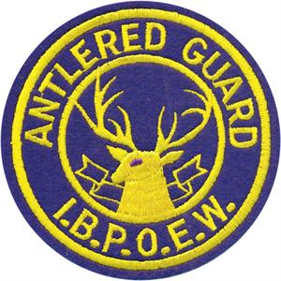 Capt. Lorena Williams
Commander Eastern Division Major General Barbara Peace Brigade Clerk
Brigade Commander
6007 Prince George St.
Baltimore, MD 21207

Parade Schedule for Tri-State Association 2018

March 21-25, 2018 – National Antlered Guard Encampment – Double Tree by Hilton, Princeton, NJ

April 2018 – Crisfield Pride Lodge #194 – Crisfield, MD

May 19, 2018 – Sidney Mudd Lodge #748 – Upper Marlboro, MD

May 27, 2018 – Queen City Lodge #1051 – Salisbury, MD

June 1-3, 2018 – Columbia Lodge #85 – Washington, DC

June 15-19, 2018 – Tri-State Association Convention – New Castle, DE

June 24, 2018 – Samuel T. Hemsley Lodge #974 – Easton, MD

July 14, 2018 – Pride of Southern MD Lodge #968 – Pomonkey, MD

July 15, 2018 – Monumental Lodge #3 – Baltimore, MD

July 22, 2018 – W. Bruce Evans Lodge #380 – Fairmont Height, MD

August 4-10, 2018 – National Convention – Jacksonville, FL

August 19, 2018 – Pride of Hagerstown Lodge #278 – Hagerstown, MD

August 26, 2018 – Mountain City Lodge #382 – Frederick, MD

September 2, 2018 – Ancient City Lodge #175 – Annapolis, MD

September 9, 2018 – Pride of St. Mary’s Lodge #1120 – Valley Lee, MD

September 16, 2018 – Pride of Towson Lodge #842 – Towson, MD

September 22, 2018 – Elk Family Day – Cambridge, MD

October 7, 2018 – W.A.C. Hughes Lodge #1053 – Newburg, MD

October 19-21, 2018 – National Shrine Week – Winton, NC

October 27, 2018 – Dorchester Lodge #223 – Cambridge, MD

